**PHASE 4**

**LESSON 2**

**PRACTICE ASSISTED 3**

**SOURCE CODE:**

**IIFE.html:**

<!DOCTYPE html>

<html lang="en">

<head>

    <meta charset="UTF-8">

    <meta http-equiv="X-UA-Compatible" content="IE=edge">

    <meta name="viewport" content="width=device-width, initial-scale=1.0">

    <title>Document</title>

</head>

<body>

    <script>

        //immidiatedly invoke function expression (function)();

      (function(){

        console.log("Welcome to IIFE")

      }) ();

      //IIFE stored in temp var

      var stdid = (function(){

        var count = 0;

        return function(){

            ++count;

            return 'std'+count

        }

      })();

      console.log(stdid());

      console.log(stdid());

      console.log(stdid());

    </script>

</body>

</html>

**Output:**

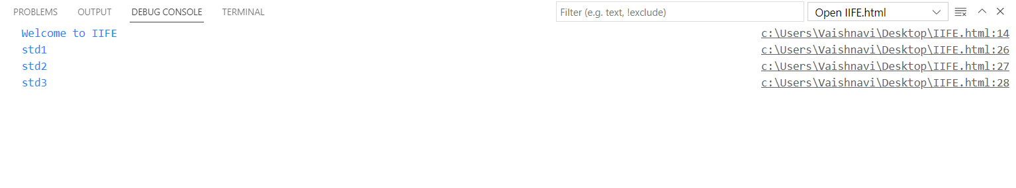

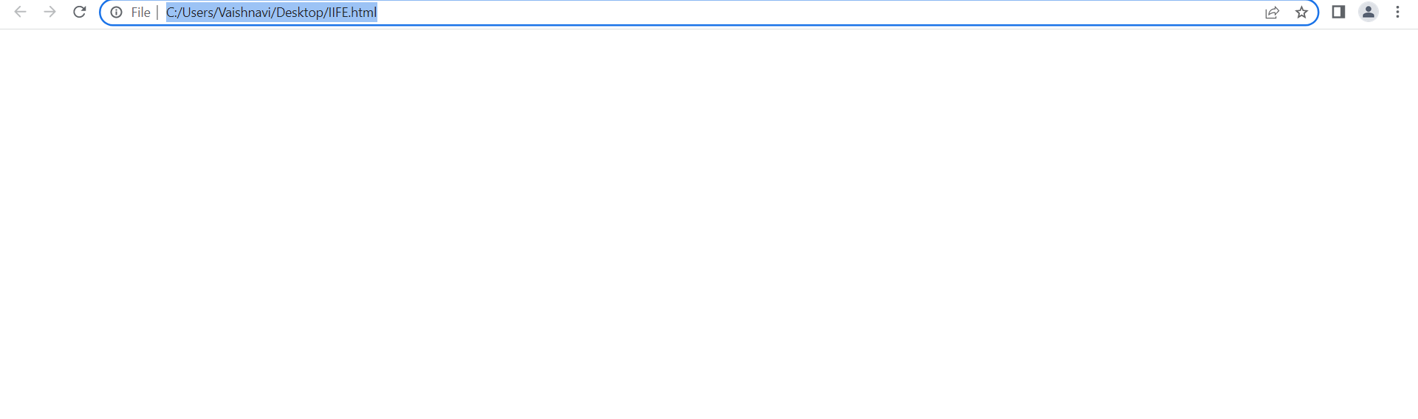

**asynccallback.html:**

<!DOCTYPE html>

<html lang="en">

<head>

    <meta charset="UTF-8">

    <meta http-equiv="X-UA-Compatible" content="IE=edge">

    <meta name="viewport" content="width=device-width, initial-scale=1.0">

    <title>Document</title>

</head>

<body>

    <script>

        function recieve(callback){

            callback();

            setTimeout(

                function(){

                    console.log("Data recieved");

                }

            ,5000);

            }

        function display(){

            console.log("Data dispaly");

        }

        recieve(display);

    </script>

</body>

</html>

**OUTPUT:**

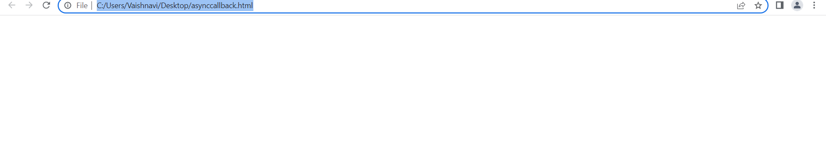

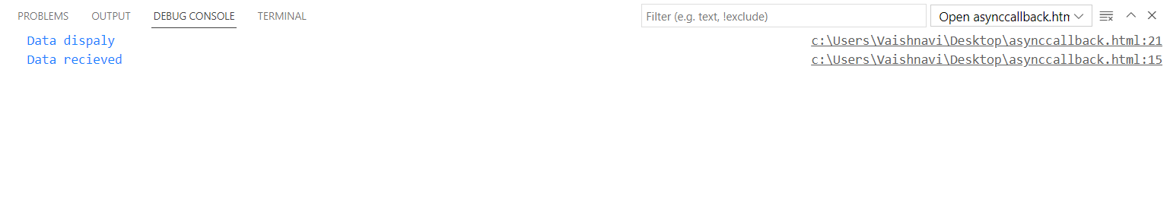

CLOSURE.HTML:

<!DOCTYPE html>

<html lang="en">

<head>

    <meta charset="UTF-8">

    <meta http-equiv="X-UA-Compatible" content="IE=edge">

    <meta name="viewport" content="width=device-width, initial-scale=1.0">

    <title>Document</title>

</head>

<body>

    <script>

        //parent block

        function test(){

            //block space

            if(true)

            {

                var a = "Hello";

                let b = 1;

                const c = 2.14;

                console.log("Let: "+b); //const and let cannot be called out of the block space

                console.log("Const: "+c);

            }

            console.log("Var: "+a);

        }

        test();

    </script>

</body>

</html>

